Screenshots
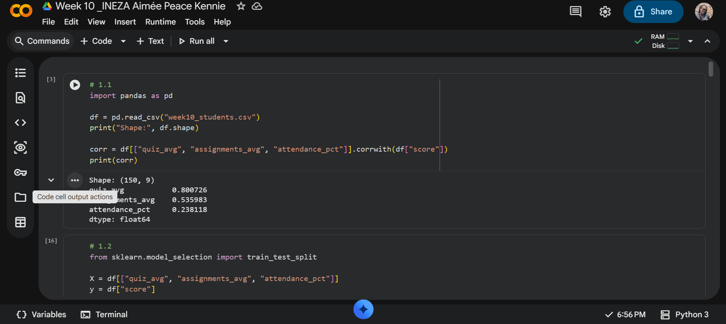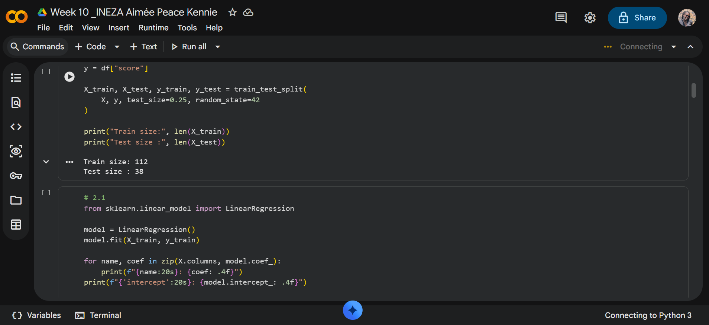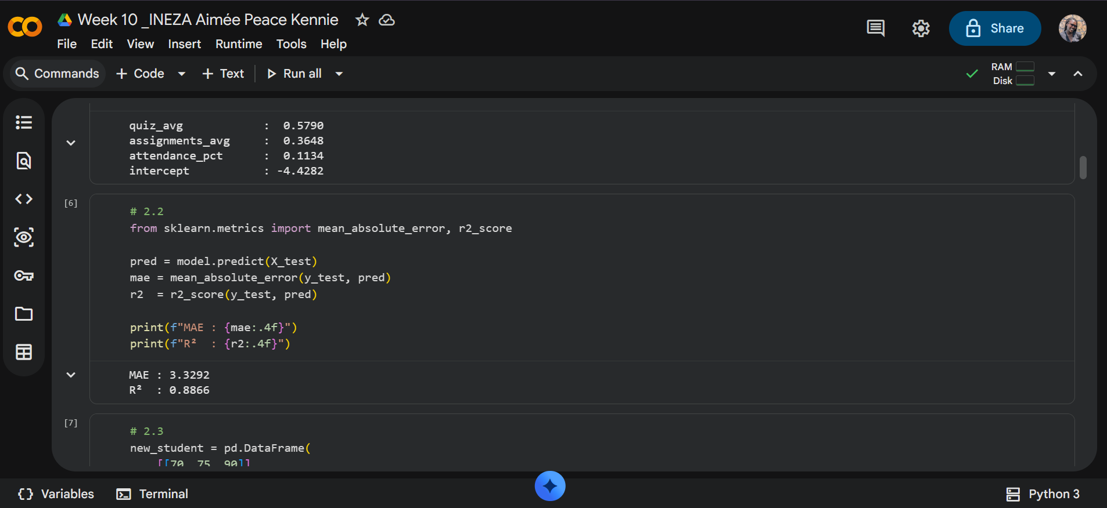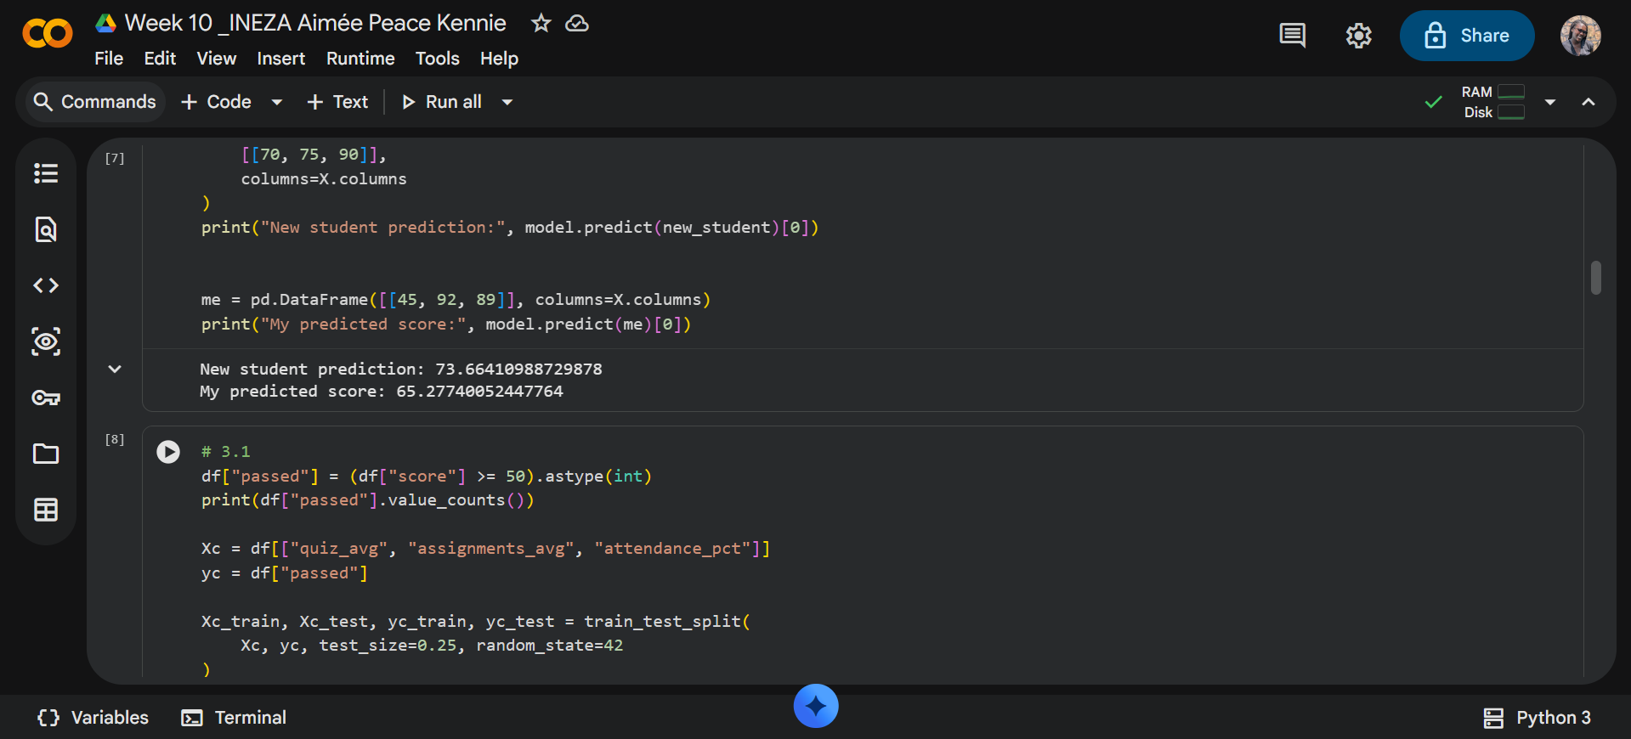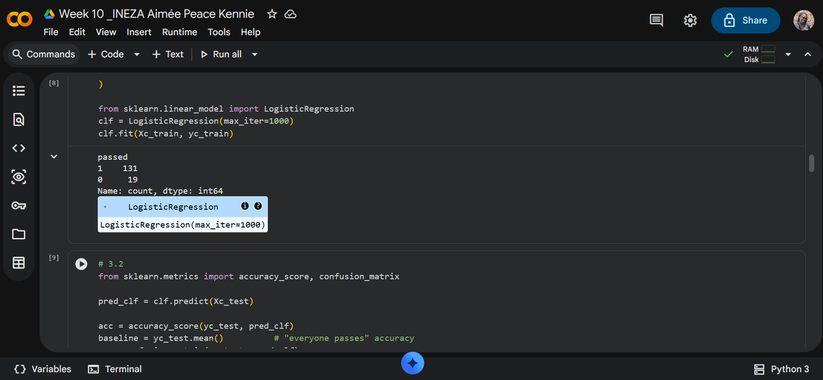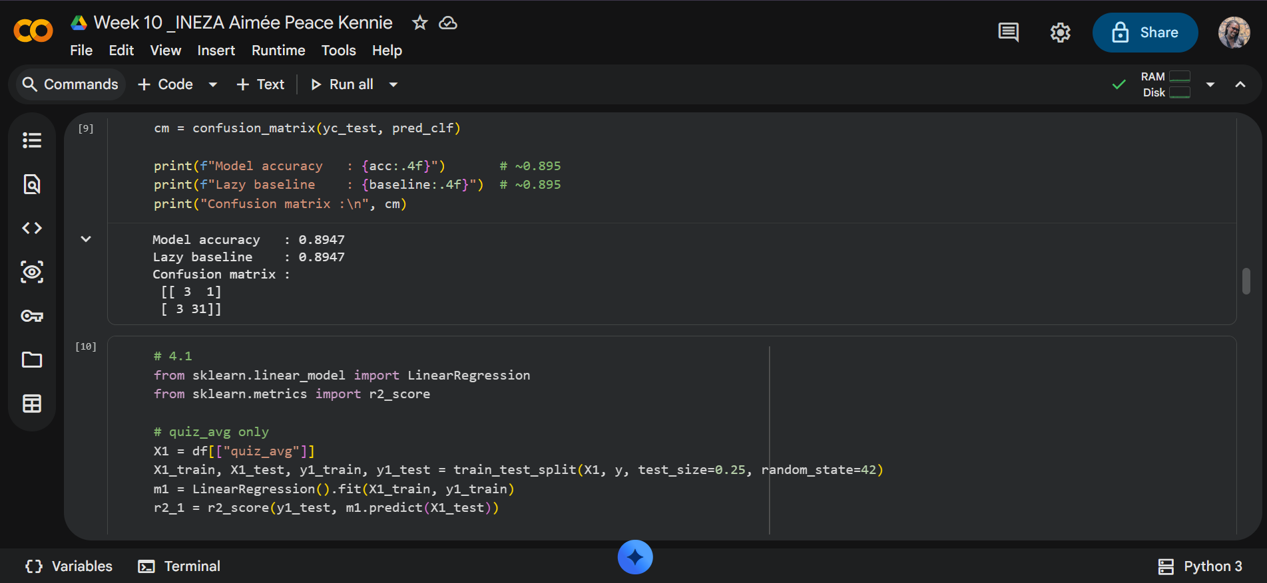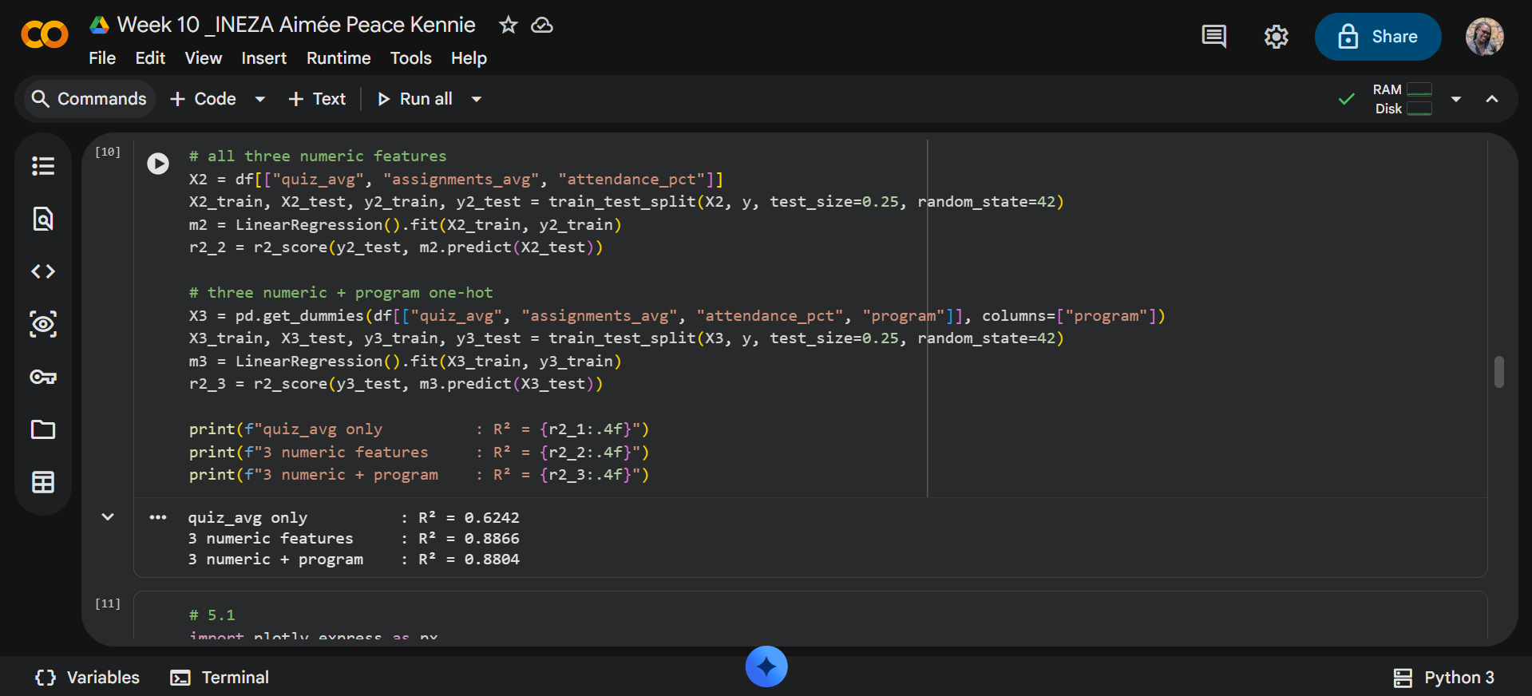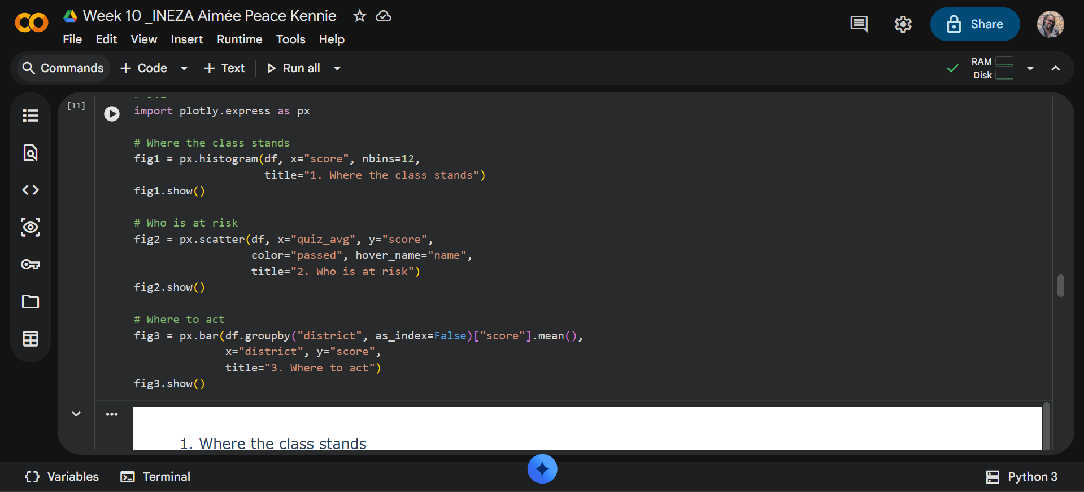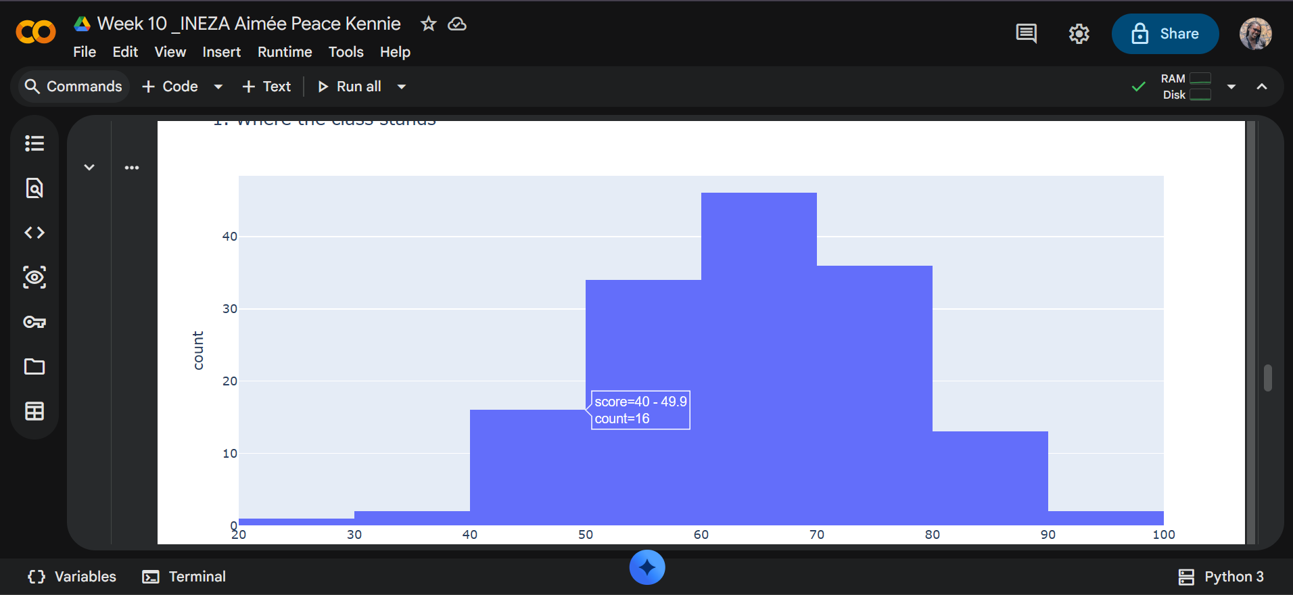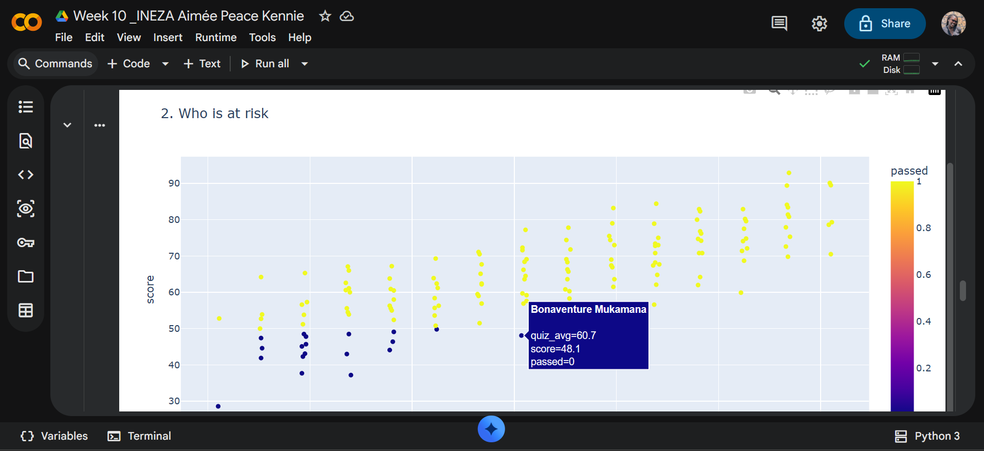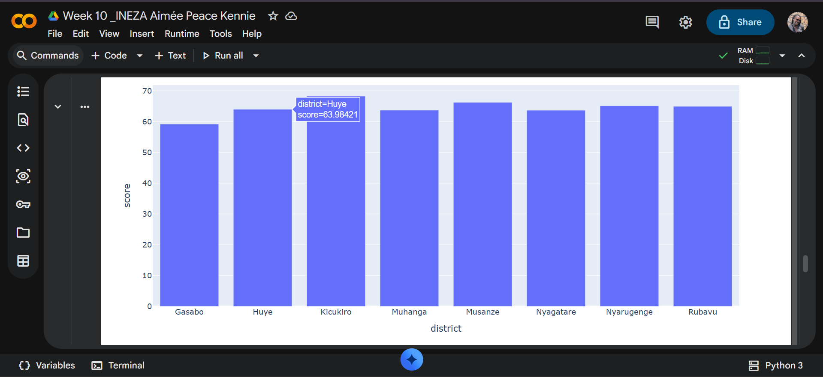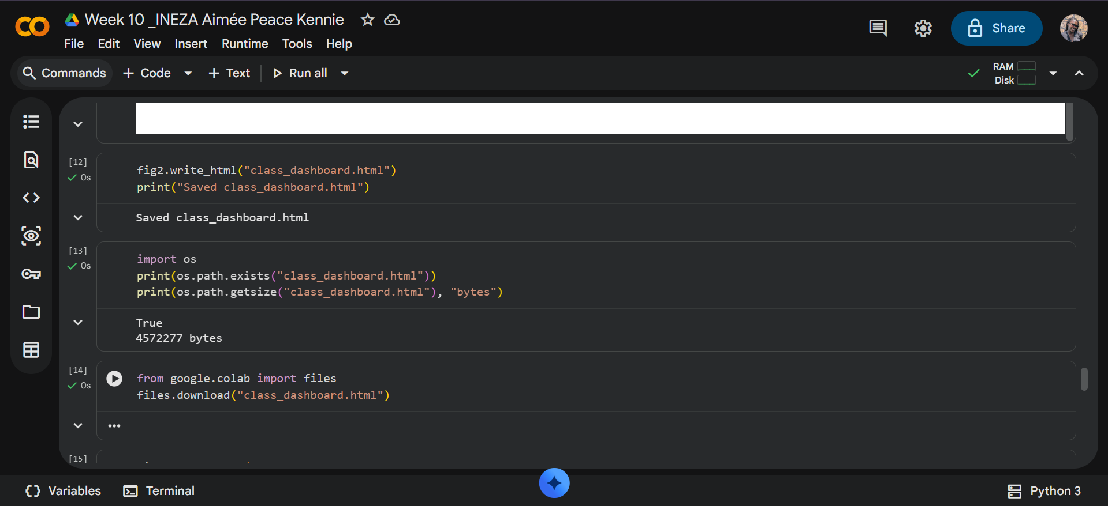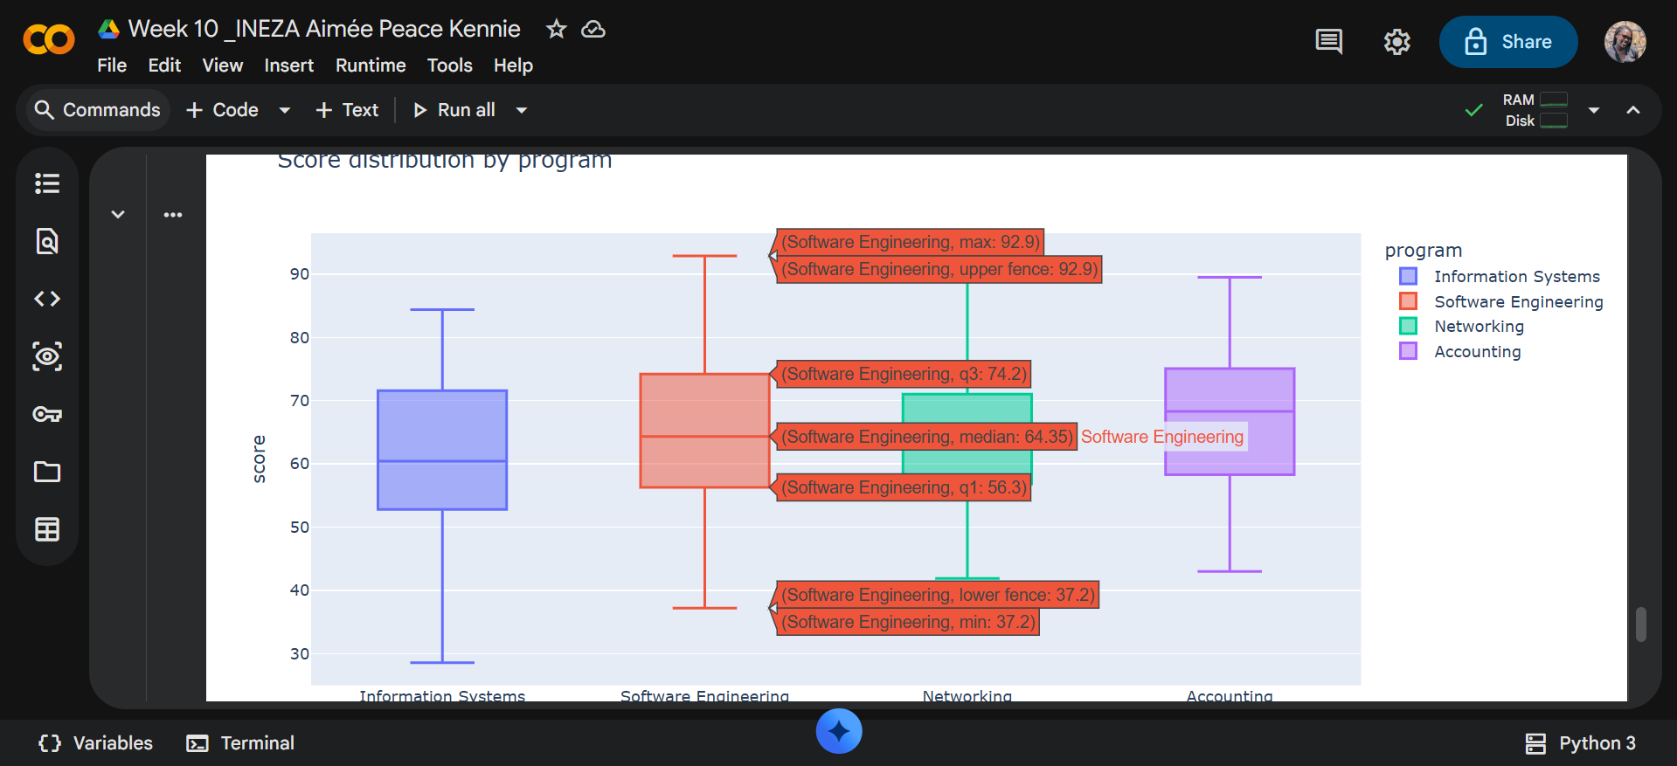

PART 6: Model Card: Student Exam Score Predictor

1. Purpose
This model predicts a student's final exam score (0–100) from their quiz
average, assignment average, and attendance percentage. It is intended for
academic advisors and lecturers as an early-warning and planning tool — to
spot students who may need support before the exam, not to grade them.

2. Data & Features
Trained on 150 clean student records (no missing values) from
week10_students.csv.
- Features (X): quiz_avg, assignments_avg, attendance_pct
- Target (y): score
- Split: 75/25 train/test with random_state=42 → 112 train / 38 test students.

3. Performance (on unseen test data)
- MAE ≈ 3.3 points: on average, the predicted score is off by about 3 points.
If the model says 70, the real score is typically between ~67 and ~73.
- R² ≈ 0.89: the model explains about 89% of the differences in students'
scores. The remaining ~11% comes from factors we did not measure
(study habits, home environment, exam-day conditions).

4. Risks & How to Use
- Who could be harmed: a student wrongly predicted to fail may face stigma,
lowered expectations, or a self-fulfilling prophecy; a student wrongly
predicted to pass may miss out on support they needed.
- How to use: as a triage flag only — to prompt a human advisor to check in
with a student and to prioritise tutoring resources. Every flag must be
paired with human judgement and the student's own input.
- How NOT to use: never for automatic pass/fail decisions, scholarship or
disciplinary decisions, or sharing a prediction with a student without
context and support.
- Bias note: the data may reflect historical inequities by district or
gender; if used at scale, the model could automate those patterns.
Subgroup error rates should be monitored before any real deployment.

